Description: How to configure GRE with IPsec between two sites routers which have connections to ISP router.

Use Case: Bank: GT Bank HQ and a Branch

Lab Environment: VMware EVE NG VM, SecureCRT.

Required Resources: Routers

Objectives:

1. Verify Router Connectivity
2. Configure Router IP Addresses
3. Configure Static or Default route
4. Configure GRE tunnel
5. Verify reachability
6. Configure OSPF
7. Verify OSPF
8. Configure IPSec and Verify

Scenario or Case Use:

You are the network administrator for a company which wants to set up a GRE tunnel to a remote office. Both networks are locally configured, and need only tunnel configure.

Definition of terms

1. GRE:
2. IPSec:
3. OSFP:
4. Protocol:

TASK

1. Design the topology-This show the network node (router, switch and PC) and the connection between each node in the network.

1. Select 3 Cisco routers.
2. Connect the Cisco routers, as express and shown in the Table and Figure below
3. Arrange the network nodes very well.
4. Label the nodes and label nodes interface and connections accordingly as they were used or connected

Addressing Table

|  |  |  |  |  |  |
| --- | --- | --- | --- | --- | --- |
| **Device**  **Name** | **Network Identity** | **Interface** | **IP Address** | **Subnet | CIDR** | **Default Gateway** |
| **R-1** | ISP | e1/0 | 101.1.1.1 | 255.255.255.0 | /24 | 101.1.1.100 |
| e1/1 | 102.1.1.1 | 255.255.255.0 | /24 | 102.1.1.100 |
| **R-2** | SITE-A | e1/0 | 101.1.1.100 | 255.255.255.0 | /24 | 101.1.1.1 |
| e1/1 | 192.168.101.1 | 255.255.255.0 | /24 |  |
| Tu0 | 172.16.1.1 | 255.255.255.252 | /30 | 172.16.1.2 |
| **R-3** | SITE-B | Tu0 | 172.16.1.2 | 255.255.255.252 | /30 | 172.16.1.1 |
| e1/0 | 102.1.1.100 | 255.255.255.0 | /24 | 102.1.1.1 |
| e1/1 | 192.168.102.1 | 255.255.255.0 | /24 |  |

Topology

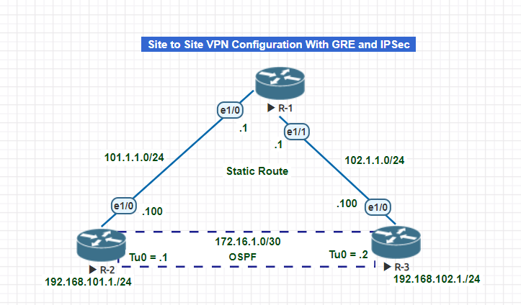

The figure above shows the topology for this lab activities

Brief Topology Description: Three router are used in the network design lab, Router labelled R-1, R-2 and R-3 are identified or also known as ISP, SITE-A and SITE-B respectively.

The following things were done to setup the goal of this lab.

Step 1: Device Identity or naming

Step 2: Interface setting: IP addressing, description etc.

Step 3: Static Route Configuration

Step 4: Create tunnel interface for GRE tunnel

Step 5: Configure source and destination IP address for tunnel

Step 6: configure OSPF routing between the two site routers

Step 7: Configure IPSec Policy, Key, transform-set (etc.) at both end

Step 8: Assign the IPSec to the GRE tunnel

Step 9: Verify IP address, ping, trace route, GRE interface, Static route, OSPF route and IPsec.

Verification of Phase 1 Configuration

Phase 1 configuration can be verified on each router by checking the following things that have been set or configured via the command line.

1. Check the interface IP Address assigned.

2. Check the interface description

3. Check interface status and protocol

The snippet below shows the output of the 3 checks. Three commands were given on the exec Mode of the cisco IOS interface. Each command could help to verified 2 things that we want to check for.

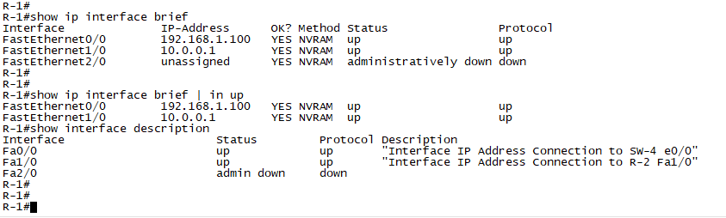

Note:

1. Similar commands for verification of Phase 1 configuration can be give on same cisco ISO Mode of router (R-2) and (R-3).
2. The equivalent output we be gotten for each of the routers.

Configuration of VPCs

To configure start the VPC and allow to run via SecureCRT.

Example: VPC-12

1. Set the Virtual PC name
2. Set the IP address value (which include NIC interface IP, Gateway interface IP and Subnet range address)
3. Save configuration

The snippet below shows how the commands have be given and the response of the VPC to each command.

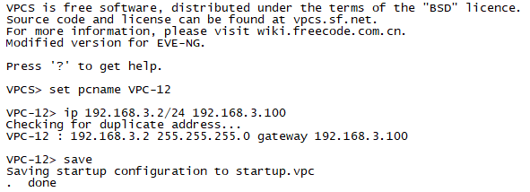

Verification of VPCs Configuration

VPC configuration can be verified on each VPC by checking the following things that have been set or configured.

1. Check the VPC name
2. Check the interface IP Address assigned.

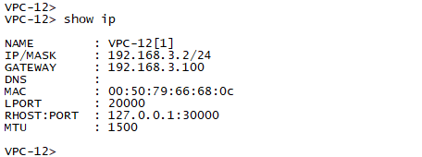

Note:

1. Same command must be used for verification of other VPCs configuration.
2. The equivalent output we be gotten for each of the VPC .